ApexPlanet Data Engineering & Analytics: Task 2

1. Executive Summary
This report documents the end-to-end data processing pipeline developed during the Data Analytics internship at ApexPlanet. The project involved Exploratory Data Analysis (EDA) to determine key growth correlations, followed by structured SQL-based business intelligence reporting.

2. Exploratory Data Analysis (EDA)
Using Python, a correlation analysis was performed on the sales dataset to evaluate the relationship between marketing expenditure, revenue generation, and customer volume.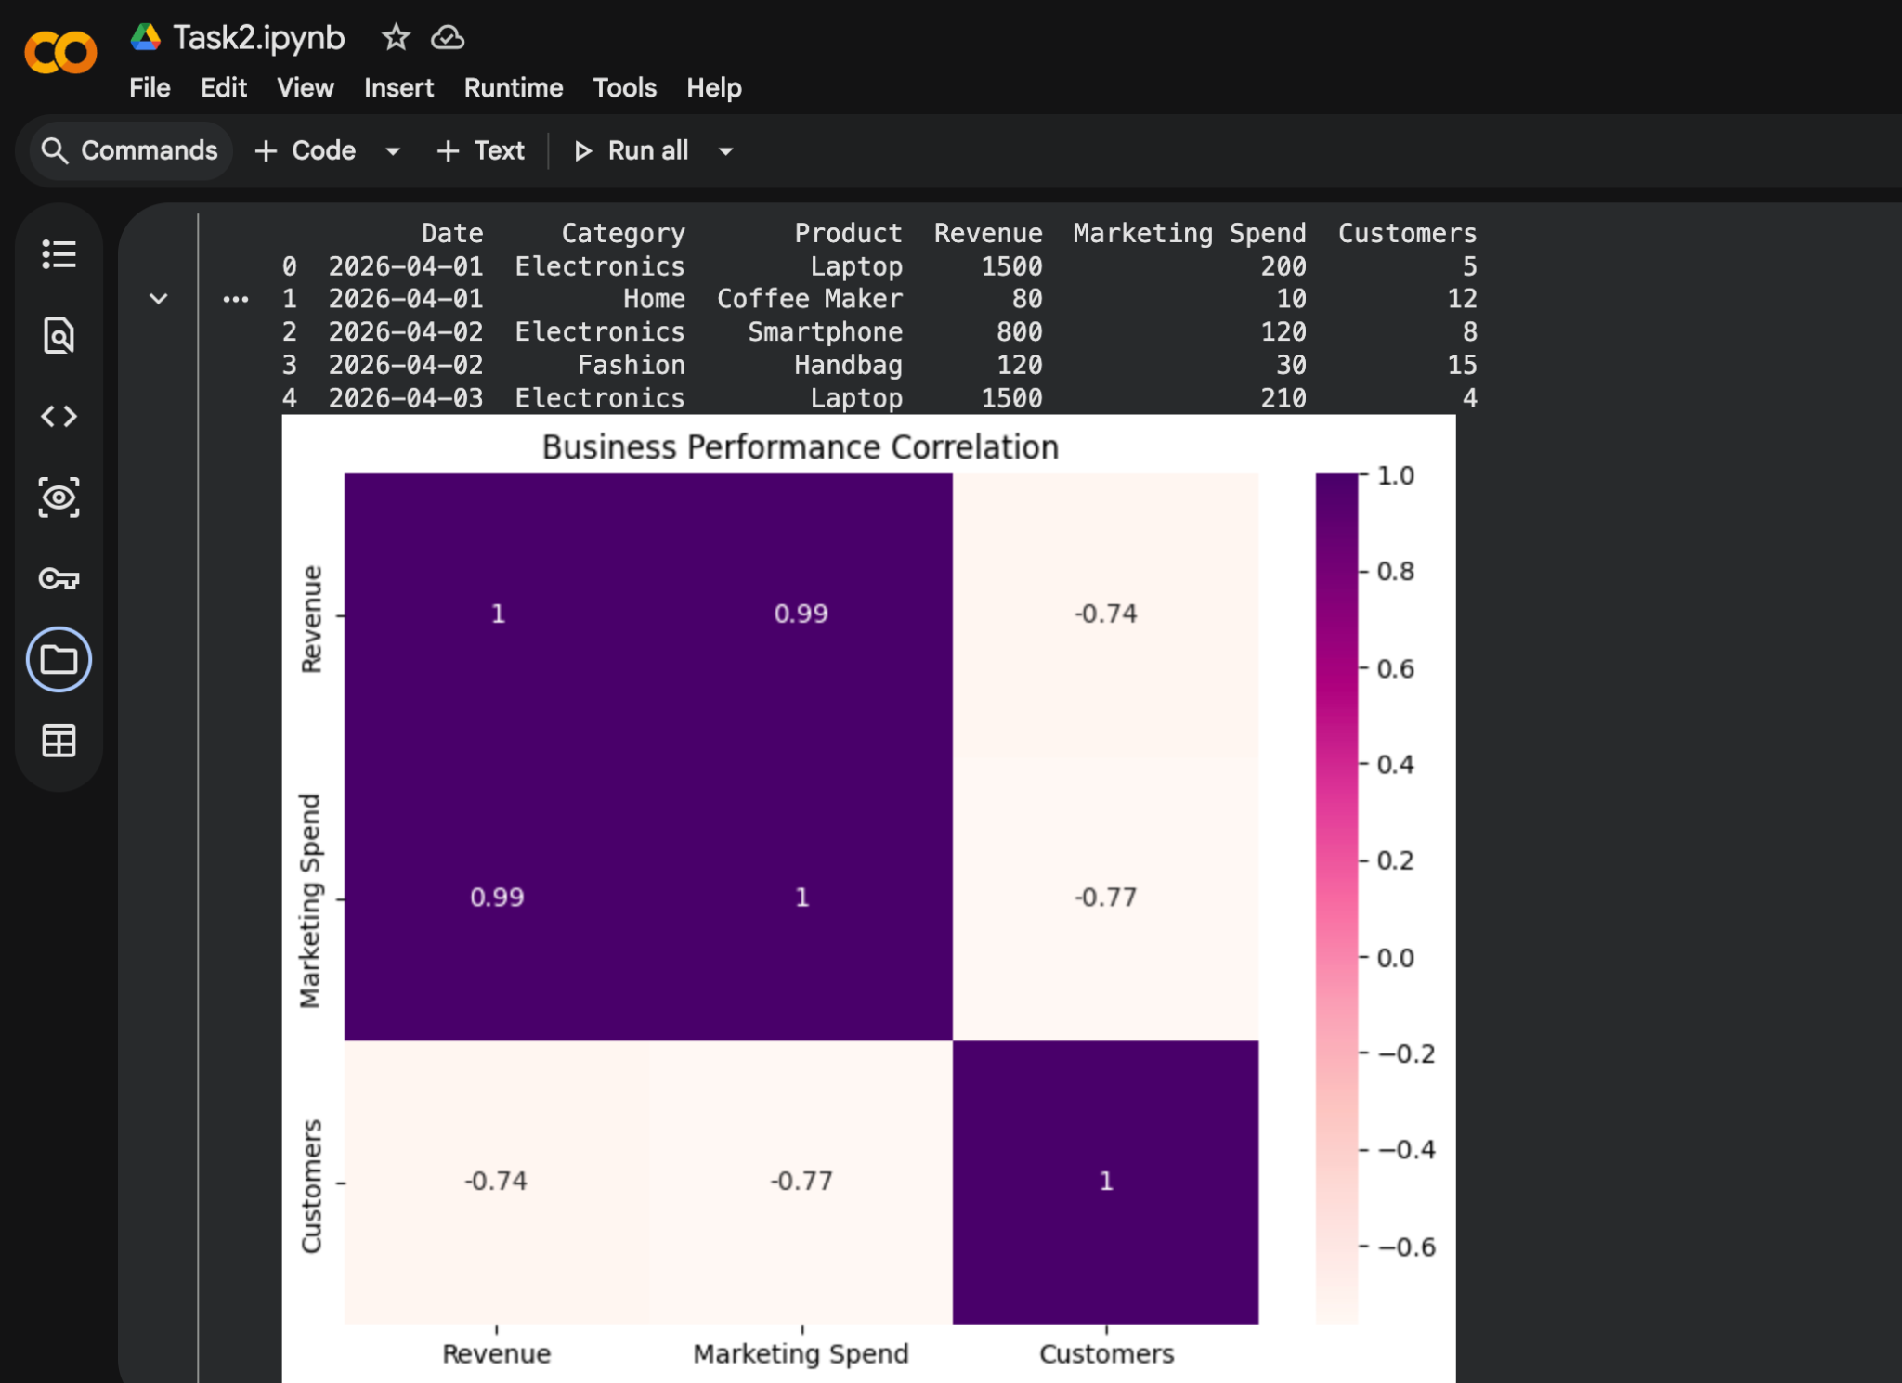
The correlation heatmap reveals a strong positive correlation (0.99) between Marketing Spend and Revenue, justifying current allocation strategies.

3. Business Intelligence & SQL Reporting
To provide actionable operational metrics, the data was loaded into a relational database schema. The following master query was executed to derive performance KPIs.

SQL Master Query
SELECT
Category,
COUNT(Product) AS Total_Products_Sold,
SUM(Revenue) AS Total_Revenue,
SUM(Marketing_Spend) AS Total_Marketing_Spend,
ROUND(SUM(Revenue) * 1.0 / NULLIF(SUM(Marketing_Spend), 0), 2) AS ROI,
ROUND(SUM(Revenue) * 1.0 / NULLIF(SUM(Customers), 0), 2) AS Revenue_Per_Customer
FROM Sales_Data
GROUP BY Category
ORDER BY Total_Revenue DESC;

Final SQL Performance Report

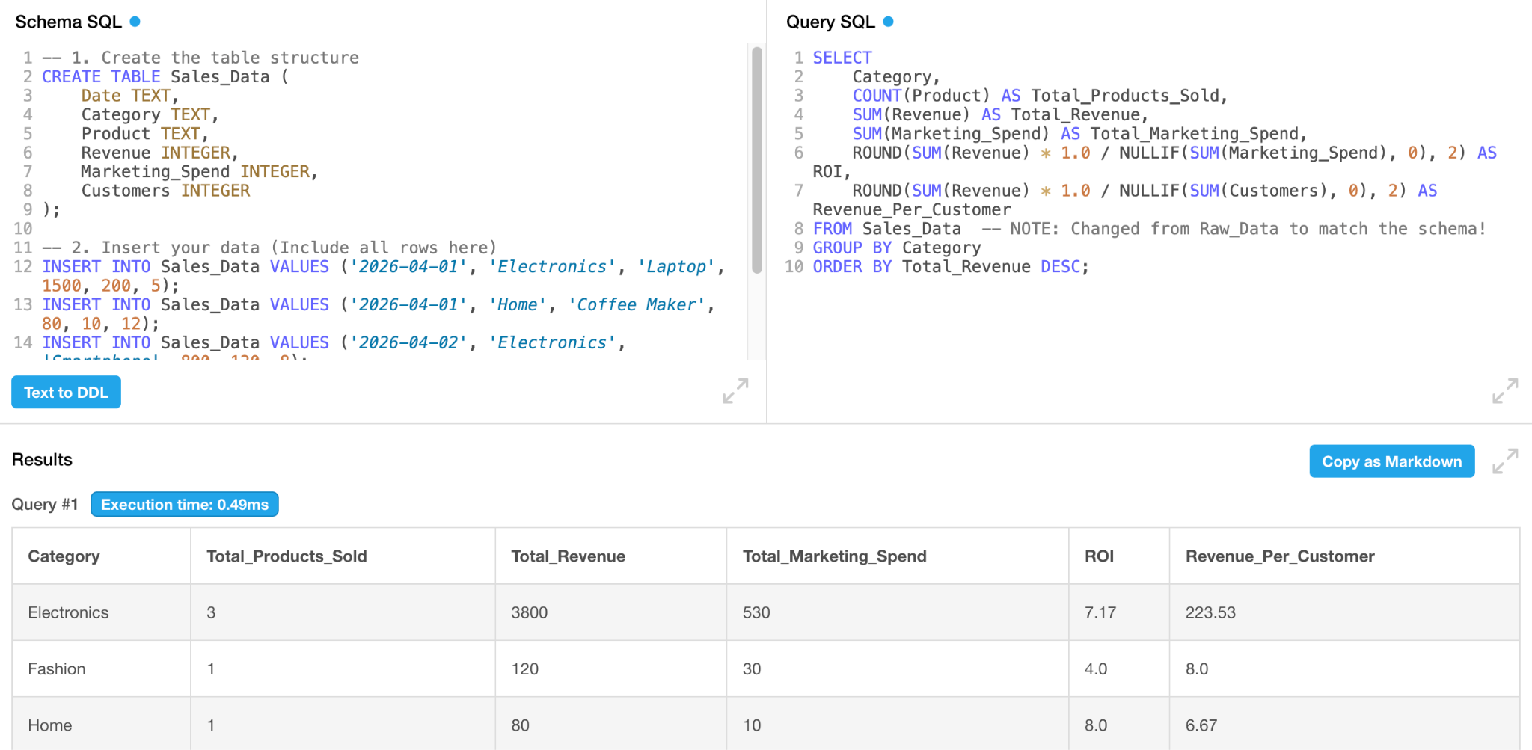

4. Conclusion
The analysis confirms that marketing spend is highly effective in driving revenue. Future strategy should focus on increasing the 'Revenue Per Customer' metric through targeted cross-selling in the high-ROI Electronics and Fashion segments.

